물리적 설계단계는 특정 DBMS와 관련성을 맺는다...
현재 DBMS 제품들이 너무나도 많아서 어디에 초점을 맞춰야 되나...하는 고민에 빠질 수도 있다...
그러나...우리에겐 표준이 있지 않는가??

Transformation Rules and SQL Constructs

-one-to-one, both entities mandatory
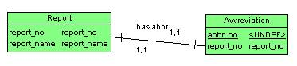

Every report has one abbreviation, and every abbreviation represents exactly one report.
create table report(
report_no interger
, report_name varchar(256)
, primary key(report_no);

create table abbreviation(
abbr_no char(6)
, report_no integer not null unique
, primary key (abbr_no)
, foreign key (report_no) reference report
on delete cascade on update cascade);

-참고
-1:1의 관계표시에서 | 표시는 적어도 대응되는 원소가 하나가 있어야 함을 의미한다.
그 위에 has-abbr은 관계의 이름을 나타내며 1.1에서 처음의 1의 의미는 최소 카디날리티, 두번째의 1은 최대 카디날리티를 의미한다. 즉, 1.1의 의미는 값을 꼭 가지고 있으나 많아야 하나의 값만을 가질 수 있다는 의미이다..다시 말하면 완벽한 1:1관계를 갖는 관계인 것이다.
-앞으로 나올 1:다의 관계에서는 다측을 닭발 표시로 나타낼 것이다.

-One-to one, one entity optional, one mandatory
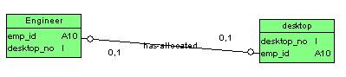

-Every department must have a manager, but an employee can be a manager of at most one department

-create table department(
dept_no interger
, dept_name char(20)
, mgr_id char(10) not null unique
, primary key(dept_no)
, foreign key(mgr_id) references employee on delete set default on update cascade
);

-One-to-one, both entities optional
-Some desktop computers are allocated to engineers but not necessarily to all engineers.

-create table engineer(
emp_id char(10)
, desktop_id interger
, primary key(emp_id);

create table desktop(
desktop_id interger
, emp_id char(10)
, primary eky (desktop_no)
, foreign key(emp_id) reference engineer on delete set null on update cascade);

-One-to-many, both entities mandatory
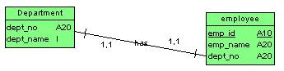
에고..employee측에 닭발 모양임다…틀린그림…
-Every employee works in exactly one department, and each department has at least one employee

create table department(
dept_no integer
, dept_name char(20)
, primary key(dept_no));

ceate table employee(
emp_id char(10)
, emp_name char(20)
, dept_no interger not null
, primary key (emp_id)
, foreign key (dept_no) references department on delete set default
on update cascade);

-One-to-many, one entities optional, on unkon
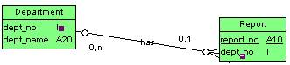

-Each department publishes one or more reports. A given report may not necessarily be published by a department.

Create table department(
Dept_no integer
, dept_name char(20)
, primary key(dept_no));

create table report(
report_no integer
, dept_no integer
, primary key (report_no)
, foreigne key (dept_no) references department on delete set null on update cascade);

-One-to-many, one entity optional, on unknown
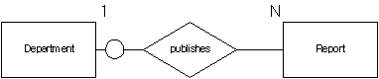

Each department publishes one or more reports.
Agiven report may not necessarily be published by a department.

Create table department(
Dept_no integer
, dep_name char(20)
, primary key (dept_no));

create table report(
report_no integer
, dept_no integer
, primary key (report_no)
, foreign key (dept_no) references department on delete set null
on update cascade);
-many-to-many, both entities optional
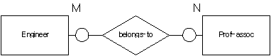
Every professional association could have none, on, or many engineer members. Each engineer could be a member of none, one, or many professional associations

Create table engineer(
Emp_id char(10)
, primary key(emp_id));
create table prof_assoc(
assoc_name varchar(256)
, primary key (assoc_name));
create table belongs_to(
emp_id char(10)
, assoc_name varchar(256)
, primary key (emp_di, assoc_name)
, foreign key (emp_id) references engineer on delete cascade
on update cascade
, foreign key(assoc_name) references prof_assoc on delete cascade
on update cascade
);

-one-to-one, both sides optional
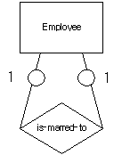

Any employee is allowed to be married to another employee in this company.

Create table employee(
Emp_id char(10)
, emp_name char(20)
, spouse_id char(10)
, primary key (emp_id)
, foreign key (spoused_id) references employee on delete set null
on update cascade);

-one-to-many, ‘one’ side mandatory, ‘many’ side optional
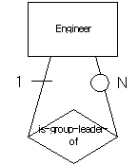
Engineers are divided into groups for certain projects.
Each group has a leader.

Create table engineer(
Emp_id char(10)
, leader_id char(10) not null
, primary key (emp_id)
, foreign key(leader_id) references engineer on delete set default
on update cascade);

-many-to-many, both sides optional
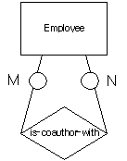
Each employee has the opportunity to coauthor a report with one or more other employee or to write the report alone.

Create table employee(
Emp_id char(10)
, emp_name char(20)
, primary key (emp_id));
create table coauthor(
author_id char(10)
, coauthor_id char(10)
, primary key(author_id, coauthor_id)
, foreign key(author_id) references employee on delete cascade
on update cascade
, foreign key(coauthor_id) references employee on delete cascade
on update cascade);

-one-to-one-to-one ternary relationship
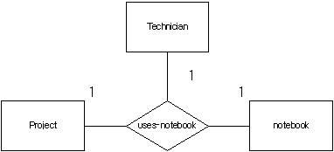

Atechnician uses exactly one notebook for each project. Each notbook belongs to one that a technician may still work on many projects and maintain defferent notebooks for different projects.

Create table technician (
Emp_id char(10)
, primary key (emp_id));

create table project(
project_name char(20)
, primary key(project_name));

create table notebook(
notebook_no integer
, primary key(notebook_no));

create table uses_notebook (
emp_id char(10)
, project_name char(20)
, notebook_no integer not null
, primary key(emp_id, project_name)
. foreign key(emp_id) references technician on delete cascade
on update cascade
, foreign key(notebook_no) references notebooke on delete cascade
on update cascade
, unique (emp_id, notebook)no)
, unique (project_name, notebook_no));

uses_notebook
Emp_id | Project_name | Notebook_no
35 | Alpha | 5001
35 | Gamma | 2008
42 | Delta | 1004
42 | Epsilon | 3005
81 | Gamma | 1007
93 | Alpha | 1009
93 | beta | 500

Functional dependencies
Emp_id, project_name→ notebook_no
Emp_id, notebook_no → project_name
Project_name, notebook_no→emp_id

-one-to-one-to-many ternary relationships
Each employee assigned to a project works at only on location for that project but can be at a different location for a different project. At a given location, an employee works on only one project. At a particular location, there can many employees assigned to a given project.

Create table employee(
Emp_id char(10)
, emp_name char(20)
, primary key (emp_id));

create table project(
project_name char(20)
, primary key(project_name));
create table location (
loc_name char(15)
, primary key (loc_name));
create table assigned_to(
emp_id char(10)
, project_name char(20)
, loc_name char(15) not null
, primary key (emp_id, project_name)
, foreign key (emp_id) references employee on delete cascade
on update cascade
, foreign key (project_name) references project on delete cascade
on update cascade
, foreign key (loc_name) references location on delete cascade
on update cascade
, unique (emp_id, loc_name));

assigned-to
Emp_id | Project_name | Loc_name
48101 | Forest | B66
48101 | Ocean | E71
20702 | Ocean | A12
20702 | River | D54
51266 | River | G14
51266 | Ocean | A12
76323 | hills | B66

Functional dependencies
Emp_id, loc_name → project_name
Emp_id, project_name → loc_name

-one-to-many-to-many ternary relationships
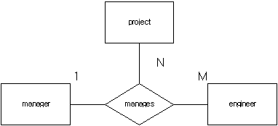

Each engineer working on a particular project has exactly on manager, but a project may have many managers and an engineer may have many managers and many project.
A manager may manage several projects.

Create table project (
Project_name char(20)
, primary key (project_name));
create table manager(
mgr_id char(10)
, primary key(mgr_id));

create table engineer(
emp_id char(10)
, primary key (emp_id));

create table manager(
project_name char(20)
, mgr_id char(10)
, emp_id char(10)
, primary key (project_name, emp_id)
, foreign key (project_name) references project on delete cascade
on update cascade
, foreign key (mgr_id) references manager on delete cascade
on update cascade
, foreign key (emp_id) references engineer on delete cascade
on update cascade);

manages
Project_name | Emp_id | Mgr_id
Alpha | 4106 | 27
Alpha | 4200 | 27
Beta | 7033 | 32
Beta | 4200 | 14
Gamma | 4106 | 71
Delta | 7033 | 55
Delta | 4106 | 39
iota | 4106 | 27

Functional dependencies
Project_name, emp_id →mgr_id

-many-to-many-to-many ternary relationships
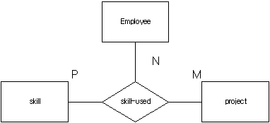

employee can use different skills on any one of many projects, and each project has many employees with various skills.

Create table employee(
Emp_id char(10)
, emp_name char(20)
, primary key (emp_id));

create table skill(
skill_type char(15)
, primary key (skill_type));
create table project(
project_name char(20)
, primary key(project_name));
create table skill_used(
emp_id char(10)
, skill_type char(15)
, project_name char(20)
, primary key (emp_id, skill_type, project_name)
, foreign key (emp_id) references employee on delete cascade
on update cascade
, foreign key (skill_type) references skill on delete cascade
on update cascade
, foreign key (project_name) references project on delete cascade
on update cascade);

skill-used
Emp_id | Skill_type | Project_name
101 | Algebra | electronics
101 | Calculus | electronics
101 | Algebra | mechanics
101 | Geometry | mechanics
102 | Algebra | electronics
102 | Set theory | electronics
102 | Geometry | mechanics
105 | topology | mechanics

Functional dependencies
None

-generalization abstraction transformation rules
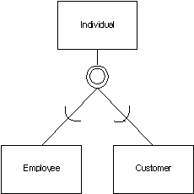
An individual may be either an employee or a customer or both or neither

Create table individual(
Indiv_id char(10)
, indiv_name char(20)
, indiv_addr char(20)
, primary key (indiv_id));

create table employee(
emp_id char(10)
, job_title char915)
, primary key (emp_id)
, foreign key (emp_id) references individual on delete cascade
on update cascade);

create table customer(
cust_no char(10)
, cust_credit char(12)
, primary key (cust_no)
, foreign key (cust_no) references individual on delete cascade
on update cascade);

